**Ampli Bioreactor Lesson Plan**

**Little Devices Lab, MIT, May 2017**

**Primary Objective**

For several decades, science classes have excelled at teaching specific reactions and metabolic pathways, but large-scale production industries still remain a mystery to students.  This activity demystifies the tubes, chambers, and other technologies of chemical factories, even allowing students to create their own industrial plant to produce ethanol and other products. This biological breadboard is designed for rapid prototyping of biochemical experiments. It eliminates traditional formats involving glassware and pipettes and transforms linear protocols (aka “cookbook” labs) into non-linear biochemical design exercises we call programmable biology. Students can use our system to explore energy concepts, without expensive instruments or laboratory infrastructure. Our Ampli Bioreactor Construction aims to bring these lessons to the classroom so that students of all ages see the potential of not just appreciating sustainable energy sources but look forward to engineering them. It is a combination of a design platform that brings creativity and modularity to learning in an application that can foster societal and environmental good.

**Introduction to Biochemical Factories:**

The teachers will discuss the fundamentals of an ethanol plant, showing students how these massive factories can convert feedstocks into useful products, such as ethanol. Subsequently, we will introduce the importance of discovering sustainable energy sources that can help meet the world’s energy requirements. The world’s demand for energy continues to skyrocket, thus discovering sustainable and effective renewable energy sources is imperative. Derived from waste products, cellulosic ethanol has the potential to meet the world’s energy needs and reduce greenhouse gasses that contribute to climate change. Cellulosic ethanol has the potential to reduce greenhouse gasses by 86 percent. Today, the price of fossil fuels remains volatile, causing shortages and financial hardships to millions of families and societies around the globe.  Cellulosic biofuel has the potential to alleviate the current energy crisis, thus sending scientists scrambling to discover effective methods of large-scale production.

**Bioreactor Inoculation (Advanced):**

Students will add media and inoculate their bioreactor with *Saccaromyces cerevisiae* and the yeast will incubate for 24 hours at 30 degrees Celsius to ensure optimal growth. To investigate the impact of the carbon source, the media will contain glycerol, glucose, or sugar cane. After preparing the yeast for incubation, the students will spot the blocks with the reagents for the production of acetaldehyde, ethylene, and ethanoic acid. See Figure 5, which describes the arraignment of the blocks and the required chemical. These will dry overnight.  As the yeast grow, they will produce ethanol as a byproduct of anaerobic fermentation; students will be able to smell the ethanol after the twenty-four hours.  The ethanol from the bioreactor will flow onto the surrounding blocks, and will react with the stored reagents.  The products will accumulate on the terminating block. To evaluate the sustainability, effectiveness of their chemical factory, and the efficiency of their particular feedstock, students will use colorimetric assays and visual observations.

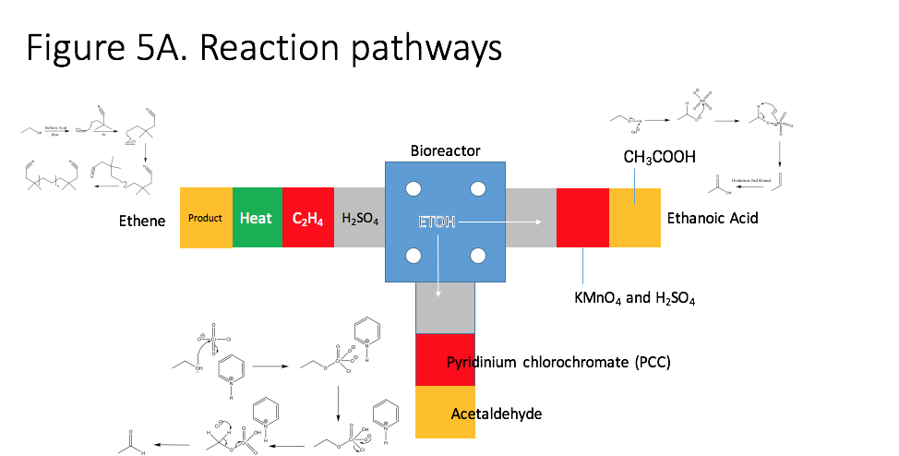

**Bioreactor Factory Construction**

Students can complete this step after inoculating their bioreactor or the following day when they return to evaluate the growth success of their yeast. For the purposes of the workshop, students will be given a pre-dosed bioreactor with ethanol already prepared due to the time constraints. This “cooking show” shortcut will not be necessary for take home exercises but will save time during the class. We estimate that this assembly will take 5 minutes. Following the provided diagrams and mechanisms, students will setup the factory using the provided blocks, ramps, and paper blocks with embedded reagents. After preparing the bioreactor, students will connect the paper swaths with the bioreactor solution, allowing the ethanol to flow onto the paper and react with the reagents.

**Analysis: Colorimetric and Calorimetric Assays**

To verify that the Biochemical Factory is functioning as desired, students will learn to measure its performance colorimetrically and via calorimetric Assay. Colorimetric assay blocks will be placed downstream of the product blocks. Colorimetric assays will confirm the presence of acetaldehyde and ethanol acid. Color changes will be assessed visually and quantified using a portable wireless color sensor driven by an Arduino.

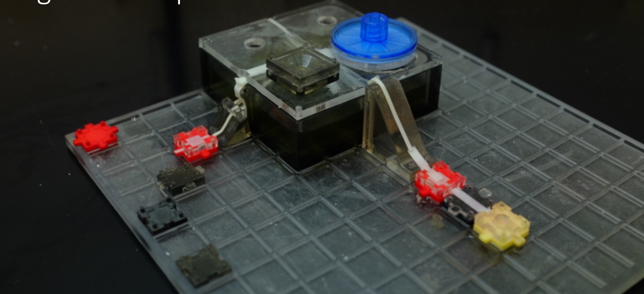

To determine the performance of the bioreactor they inoculated in producing ethanol, students will use a Calorimetric Assay: To assess the efficiency of the ethanol, students will create a calorimeter.  An alcohol burner, using the ethanol the students produced as a fuel, will heat a supplied can filled with water. Students will measure the temperature change using a bluetooth enabled thermometer of the water and record the time the ethanol burns.  With this data, they can determine the amount of energy their chemical plant produced.  They will perform the same analysis for two control samples, including biodiesel and canola oil, which allows them to compare the efficacy of their production process to other common oils and fuels.

**Evaluation & Discussion**

The students will propose modifications to the chemical factory to improve the sustainability and effectiveness of the process. For example, we will ask some groups to identify common waste products in their community that they could use as a feedstock for the ethanol. Students will explore how these alternative feedstocks will impact the production process—increase or decrease efficiency, which side reactions proliferate, is there available infrastructure to transport the feedstock to the chemical factory?  To further assess the understanding of the students, we will instruct them to design their own chemical production process on paper. Students able to complete both of these tasks will have demonstrated their understanding for how engineers and scientists design and improve chemical factories. Finally, given a series of photographs of ethanol plants, they will use scissors and glue to assemble collage blocks to identify and design their own plants. The aim of this exercise is to determine how well they have been able to demystify the confusion nest of pipes, pipes tubes and smokestacks that often comes with these types of engineering pictures.

***Alternative Lesson for Beginners***

**Bioreactor Inoculation:**

***The focus of this alternative lesson will be fermentation knowledge.*** Students will add media and inoculate their bioreactor with *Saccaromyces cerevisiae* and the yeast will incubate for 24 hours at 30 degrees Celsius to ensure optimal growth. To investigate the impact of the carbon source, the media will contain glycerol, glucose, or sugar cane. After preparing the yeast for incubation, the students will assemble the pre-fabricated blocks with the reagents for the production of acetaldehyde, ethylene, and ethanoic acid followed by pH blocks that will verify active ingredients. A pre-fermented solution of ethanol will be added to bioreactor to save time, which will flow onto the surrounding blocks, and will react with the stored reagents.  The products will accumulate on the terminating block. To evaluate the sustainability, effectiveness of their chemical factory, and the efficiency of their particular feedstock, students will use colorimetric assays and visual observations.

**Bioreactor Factory Construction**

***The focus of this alternative lesson will be flow through paperfludiic channels.*** A pre-dosed bioreactor with ethanol already prepared will be given to the students. This “cooking show” shortcut will not be necessary for take home exercises but will save time during the class. We estimate that this assembly will take 5 minutes. Following the provided diagrams and mechanisms, students will setup the factory using the provided blocks, ramps, and paper blocks with embedded reagents. Additional blocks will be provided so the students can design their own pathways. After preparing the bioreactor, students will connect the paper swaths with the bioreactor solution, allowing the ethanol to flow onto the paper and react with the reagents.

**Analysis: Colorimetric and Calorimetric Assays**

***The focus of this alternative lesson will be flow through colorimetric reactions that verify performance.*** To verify that the Biochemical Factory is functioning as desired, students will learn to measure its performance colorimetrically, Colorimetric assay blocks will be placed downstream of the product blocks. Colorimetric assays will confirm the presence of acetaldehyde and ethanol acid. Color changes will be assessed visually without electronics.

**Teacher Professional Development**

Teachers seeking to teach complex biochemical processes using easy to understand lessons often resort to representative models, which are not as impactful or exciting as functional ones. It’s the same reason why a chemical model is not as exciting for many students as a real working electric motor. While other fields such as robotics and physics enjoy many examples of functional experiments, life sciences is still catching up.

Traditional approaches to biochemical lessons encourage investments in advanced laboratories that may not be affordable to all schools. We believe teachers can learn how to create functional examples of biochemical lesson plan without preconceived expectations that it should be infrastructure intensive.

Using Ampli blocks, teachers will explore the myriad applications of models, especially in illustrating intricate and foreign concepts. Teachers will translate complex material in the classroom to an interactive activity that sheds light on a complex process. This project will help them develop strategies to show students how information they learn in the classroom can help solve tangible problems in everyday life, such as renewable energy, sustainability, and polymer synthesis.

Teachers generally teach students the tools to predict a chemical reaction, solve a differential equation, and understand metabolic processes; however, teachers often falter when confronted with the age-old question: why does this matter?  Armed with the strategies developed in this class, teachers can illustrate how chemical reaction produce products we use in our daily life, how differential equations helped model these chemical processes, and how those who understand metabolic pathways can employ microorganisms for the production of biofuels, drugs, beverages, and numerous other useful items. Depending on the age group, not all these questions will arise, but they will learn to explain fundamental lessons of the practical applications of the science lesson.

Returning to their classrooms, teachers can develop their own integrated lesson plans that address relevant world problems using this renewable energy project as a model. Implementing knowledge in real-life scenarios helps students imbed the concepts, leading to deeper student learning and understanding. Tangible projects help demystify complex concepts and cement the information. Indeed, pure memorization may help the student recite a specific fact, but he or she will most probably fail to apply the information in a new context or scenario. However, if students actually use the information to solve a problem (design a chemical plants), they will develop a deeper understanding of the topic and gain confidence in addressing other more complex problems and ideas.

Technical capacity building will include the construction, maintenance, and on going operation of the Ampli Bioreactor Construction Set. Teachers will learn how the Construction Set was developed, how we boiled down the individual elements, and how to employ Design for Hack strategies that will welcome their own modifications to the system. Additionally, we will introduce the basics of how sensors can couple to a data gathering platform in both SD cards and real time wireless communications using Android phones. Finally, we will explore at how teachers can recreate the basics of the lesson plan using locally available materials to gauge their understanding of the lesson and the technology behind it.

**Module Relevance:**

For several decades, science classes have excelled at teaching specific reactions and metabolic pathways, but large-scale production industries still remain a mystery to students.  This activity demystifies the tubes, chambers, and other technologies of chemical factories, even allowing students to create their own industrial plant to produce ethanol and other products.

The world’s demand for energy continues to skyrocket, thus discovering sustainable and effective renewable energy sources is imperative. Derived from waste products, cellulosic ethanol has the potential to meet the world’s energy needs and reduce greenhouse gasses that contribute to climate change. Cellulosic ethanol has the potential to reduce greenhouse gasses by 86 percent. Although society may consider ethanol as a novel invention, Henry Ford’s first vehicles ran on ethanol. Cheaper than gasoline, ethanol remained the fuel of choice until 1901 when the Texas oil fields were discovered, dropping the cost of gasoline below that of ethanol.  Today, the price of fossil fuels remains volatile, causing shortages and financial hardships to millions of families and societies around the globe.  Cellulosic biofuel has the potential to alleviate the current energy crisis, thus sending scientists scrambling to discover effective methods of large-scale production.

Unlike other energy sources, cellulosic ethanol can remain a stable source because waste alone constitutes its mass. Today, the United States uses corn kernels to create most of its ethanol biofuel. Aside from the fluctuating costs, this creates a conflict with food production and raises questions about the advisability of using arable land for anything but food when the world needs more food production. Cellulosic ethanol can step in to fill this void with a desperately needed alternative to ethanol produced from corn. If scientists overcome the obstacles to cheap, clean cellulosic ethanol production, then a superior, renewable energy source will be available to everyone, which could solve many of the current dilemmas surrounding energy needs.

The life sciences is frequently hailed as one the next opportunities in discovery and innovation. Our work is driven by a desire to reintroduce experimental approaches into biochemistry so that students and teachers can see biochemical processes as tools and elements of a construction set, as opposed to a rote laboratory activity that should be memorized. Moreover, we aim to embed this experimental approach with the real world applicability that has been fruitful in attracting students to toothed fields such as robotics and computer science. In our own research, biochemistry is our construction set and it involves non-linear creative thinking. We aim to share that with educators and their students with Ampli.